CSC 351 Operating Systems
KPA Semester Project Description
Fall 2026
Dr. Wheat

This is a semester-long team project that is broken into two phases with five deliverables per phase. A rubric associated with this project is posted on D2L.
Phase 1 is to implement an ext2 file system simulation, as described in chapters 13 and 14 of the textbook.
Phase 2 is to implement a shell program, similar in behavior as the Bourne shell to exercise the phase 1 implementation.
Each phase has the following five deliverables:
- Requirements document
- Design Document
- Gannt Chart for the development of the project
- A demonstration of the program working properly
- A teaming assessment.
Each team member is responsible for submitting each deliverable item. The first four deliverables shall be the same packages for each team member on the same team. The fifth deliverable is unique to each team member.
NOTE: The two phases overlap in deliverables. I.e., phase 2 starts long before phase 1 is completed.
Assignment Description
Overview
The filesystem (FS) shall be implemented in a user-level C++ program consisting of an appropriate number of source and header files. The FS shall be sized at 2GB of raw storage and shall be implemented within a file on the computer. The program shall have the ability to create the file system, upon request. Otherwise, the program shall service file operations as requested by another program, the Shell. The two programs shall communicate via TCP sockets. When the FS is told to shut down, the FS program shall terminate cleanly. Upon starting again, the FS shall be in the same state as it was when it shut down.
Phase 1 Description
The FS shall support at least the iNode fields shown in this figure.

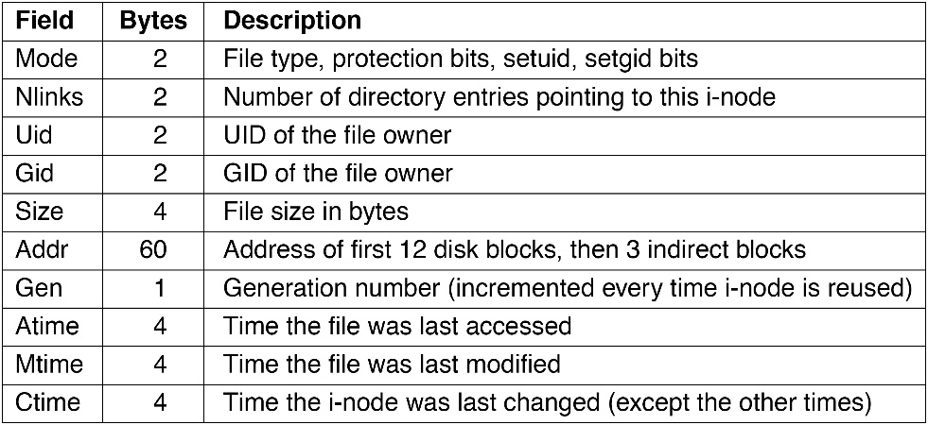
Additionally, a fourth Time field should be captured, and that is the time that the iNode gets allocated for the file, representing the birth time of the file. Other fields can be created/used but must be fully documented.
The FS shall implement a simple file-descriptor table for all open files.
The FS shall use a 4KB block size and, for each time a file needs to be lengthened, it shall allocate one or more blocks as needed.
The FS shall support the system calls noted in this figure.
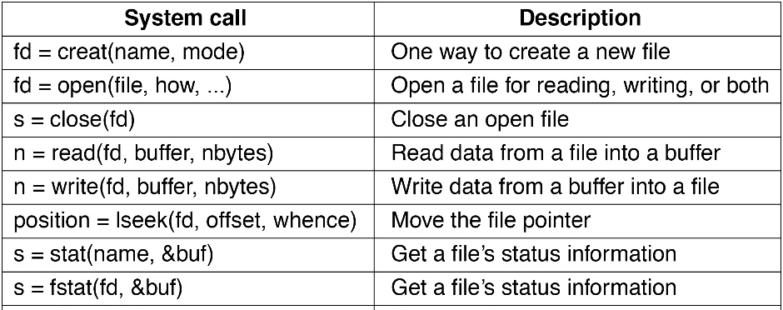
However, the function names shall be prepended with “my_”; e.g., create() will be called my_create(). This is to distinguish these functions from the real filesystem functions in the operating system.
This figure shows the fields to be returned by the my_stat() function. 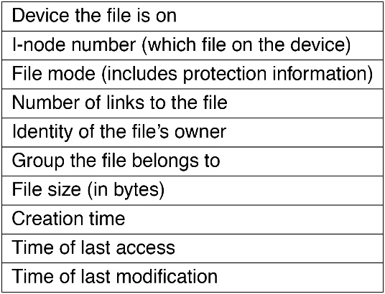
The device name shall be “mydev”.
Similarly, the FS shall implement all the system calls this figure.
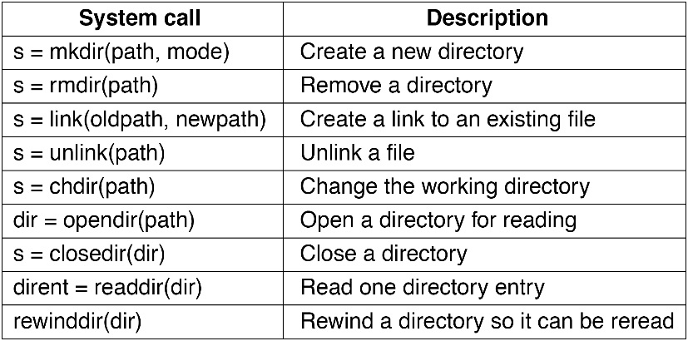
For Phase 1, the umask shall remain at its default, 0777 for directories and 0666 for files. Likewise, the UID:GID will stay at the default value of 0:0.
The demonstration of the FS will require a client application to be developed, much along the same lines as the Phase 2 shell. It will be a shell that allows the following calls to be made:
- ls – provide the equivalent of a “ls -l” long output of the current directory.
- cd – change directory to the given directory
- mkdir – make a directory with the name given.
- lcp – copy a host file to the current directory in the FS
- Lcp – copy a FS file from the current directory to the current directory in the host system
- touch – create a new empty file or update the modification date of an existing file or directory
- stat – stat a file or directory
- shutdown – shutdown and terminate the FS and the shell.
- exit – causes the Shell to terminate, allowing the FS to make a connection to yet another shell.
Start the FS process, kpaFS, with these options.
- -f filename which is the name of the backing store to be created or read from.
- -c – optional feature for specifying that the backing store is to be created; also requires these options:
  - -i xxx, where xxx is a decimal number representing the number of iNodes to use.
  - -b yyy, where yyy is a decimal number of the block size in K. 10 means 10240 blocks.
- -p portNumber --- optional feature; defaults to 8080
- -d zzz – optional feature that turns on debug level zzz where zzz is a non-negative integer. The default is 0.
Example: kpaFS -f myFS.img -c -i 128 -b 5 -p 8081 -d 2 is for 128 iNodes, 5K blocks, port 8081, and level 2 debug.
When initialized, the filesystem will have a single directory “/” and its iNode number shall be 0. The gid:uid for this root directory shall be 0:0, and its permission bits shall be set to 0777.
The default permissions for files and directories shall be 0777 and 0666, respectively.
The shell will provide the umask value.
For any file or directory creation, use the uid/gid bits provided by the shell.
This first shell may be a prototype of the Phase 2 shell.
The FS demonstration needs to show each of these commands working for small and large files, with multiple directories.
The teaming report shall be done in an Excel spreadsheet. A template is provided in D2L.
Phase 2 – The Shell
The shell is a client to the FS program, with which it communicates via sockets. It is up to you as to how you coordinate which sockets are used.
The shell shall provide a prompt to the user; the prompt shall be “userPWD ->” where userPWD is the full path of the present working directory.
The shell shall take only one command per input line.
Each command is a keyword followed by zero or more arguments.
Each command is executed without dash options; for example, there will be no -R option for chown.
The arguments can be absolute or relative paths. There will be no need for wildcards in filenames.
The commands are:
- Those in Phase 1, but now allowing paths
- chmod – change the permission bits of the named files/directories; e.g., chmod 640 aFile bFile
- chown – change the ownership and group “chown 3:5 target[s]” will change the owner uid to 3 and gid to 5.
- setUIDGID – change the user:group setting of the user.
- setUmask – change the umask; use octal notation, e.g., 0644.
- rmdir – removes one or more named directories.
- cp – copy one or more FS files to a destination. When only one file is being copied, the destination can be either a filename or a directory name.
- mv – similar to cp, but moves the file(s)
- rm – removes one or more files
- ln – create a hard link; no need to support symbolic links.
- cat – print the contents of one or more files to the screen; I/O redirection does not need to be provided.
The teaming report shall be done in an Excel spreadsheet. A template is provided in D2L.
Deliverables
For each phase, the deliverables shall be:
- All the software files (.cpp, .h) and a Makefile to build both the FS and the shell
- The requirements, design, and mpp documents.
- The teaming report.
- A Zoom link containing a video demonstration of the FS in action, narrated by the team. The demonstration shall include every step, from the making of the programs, to the initial creation of the file system, to the use of the shell (with many examples), and at least two demonstrations showing the shutdown of the filesystem with subsequent resumptions, clearly showing no loss of data.

